**Web Development**

Submitted By:

Bijaya Thapa Magar

(17439839)

Table of Content

1. Introduction
2. System Navigation Diagram
3. Wireframe
4. Screen Mock-up
5. Testing & Evaluation

5.1 Responsive Webpage

5.2 Validation of Source code

5.3 Speed Test

5.4 Usability

6. Conclusion

7. Reference

1. **Introduction**

Bijaya Thapa Magar is a personal website website designed by me ( Bijaya Thapa Magar). This website is design by using HTML and CSS only. This website gives information about me. There are 4 different pages. They are index (Home) page, CV page, Bio page and at last Contact page. Home page includes short detail about me and link to different pages. CV page includes more detail about me. You can find my date of birth, parents name, education level, experience and many more. Bio page includes small bio about me. Contact page has a static contact form to contact me.

1. **System Navigation Diagram**

Contact

CV

Bio

Home

Contact form

**Fig 1 System navigation diagram**

1. **Wireframe**

Wireframe is the rough sketch on paper or in pc of a system which we are going to build.

**Home Page**

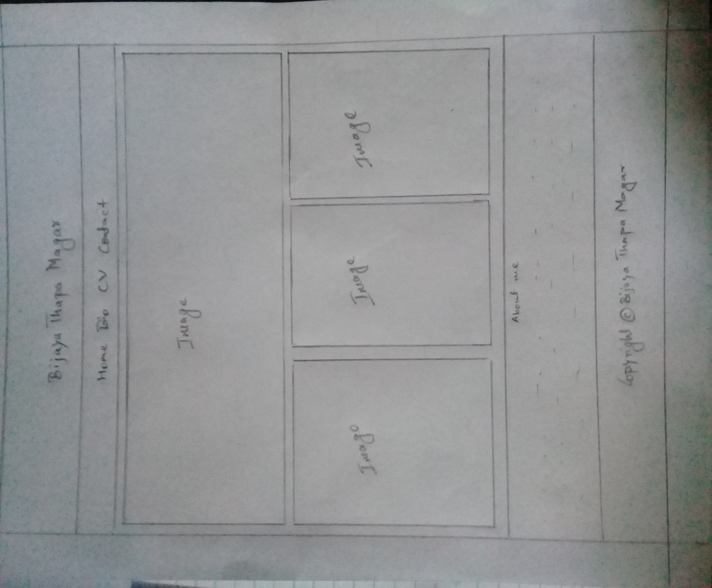**Fig 2 Wireframe of Home Page**

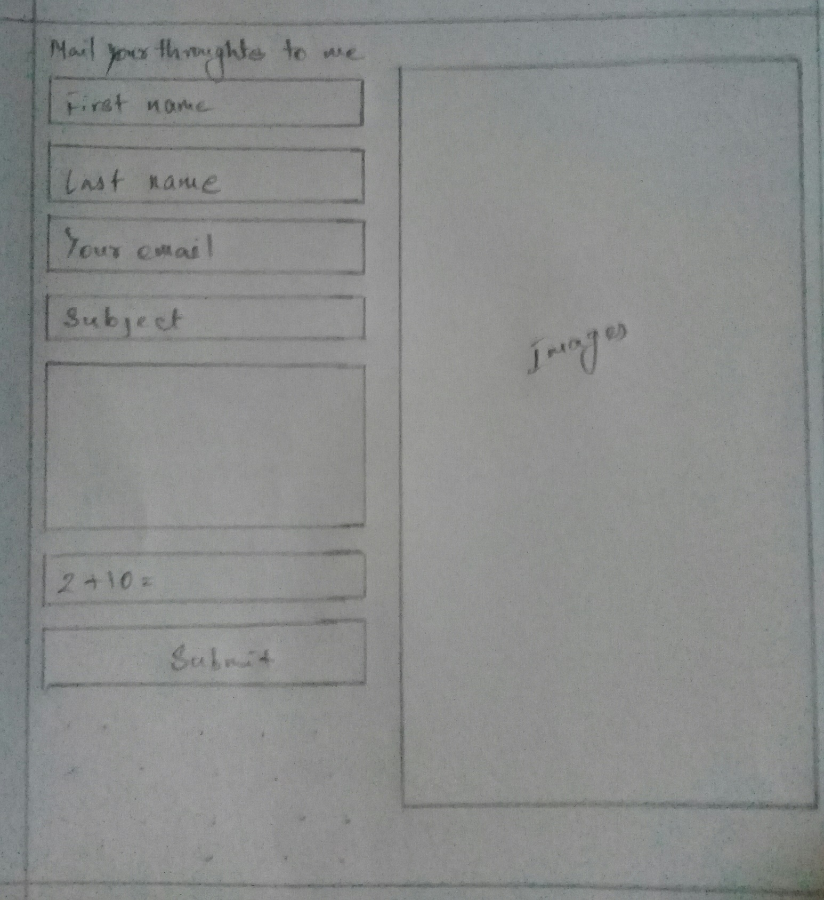**Contact Page**

**Fig 3 Wireframe of Contact Page**

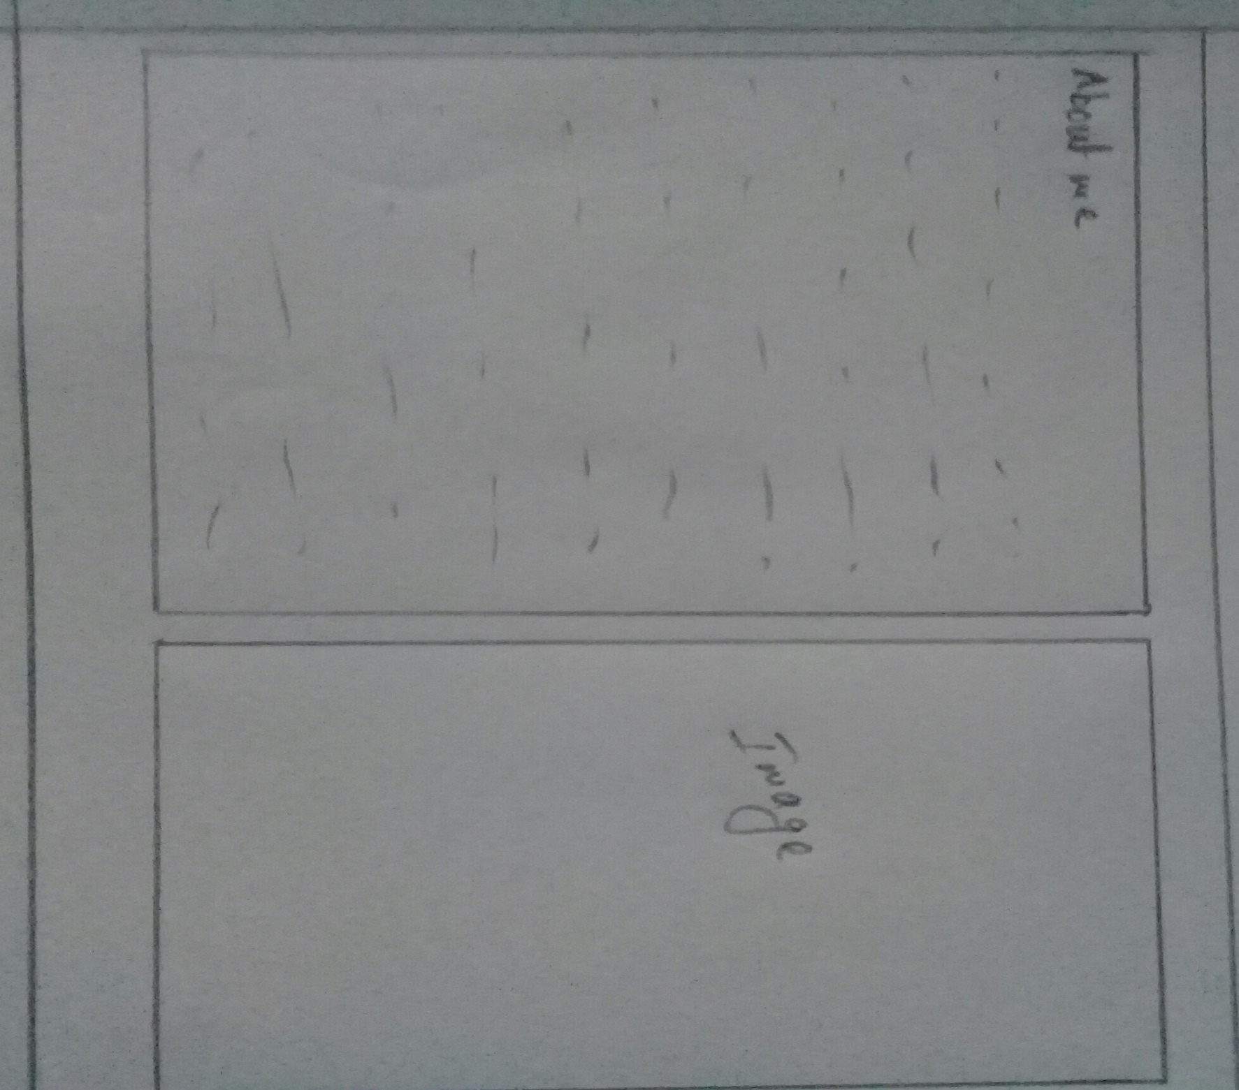**Bio Page**

**Fig 4 Wireframe of Bio page**

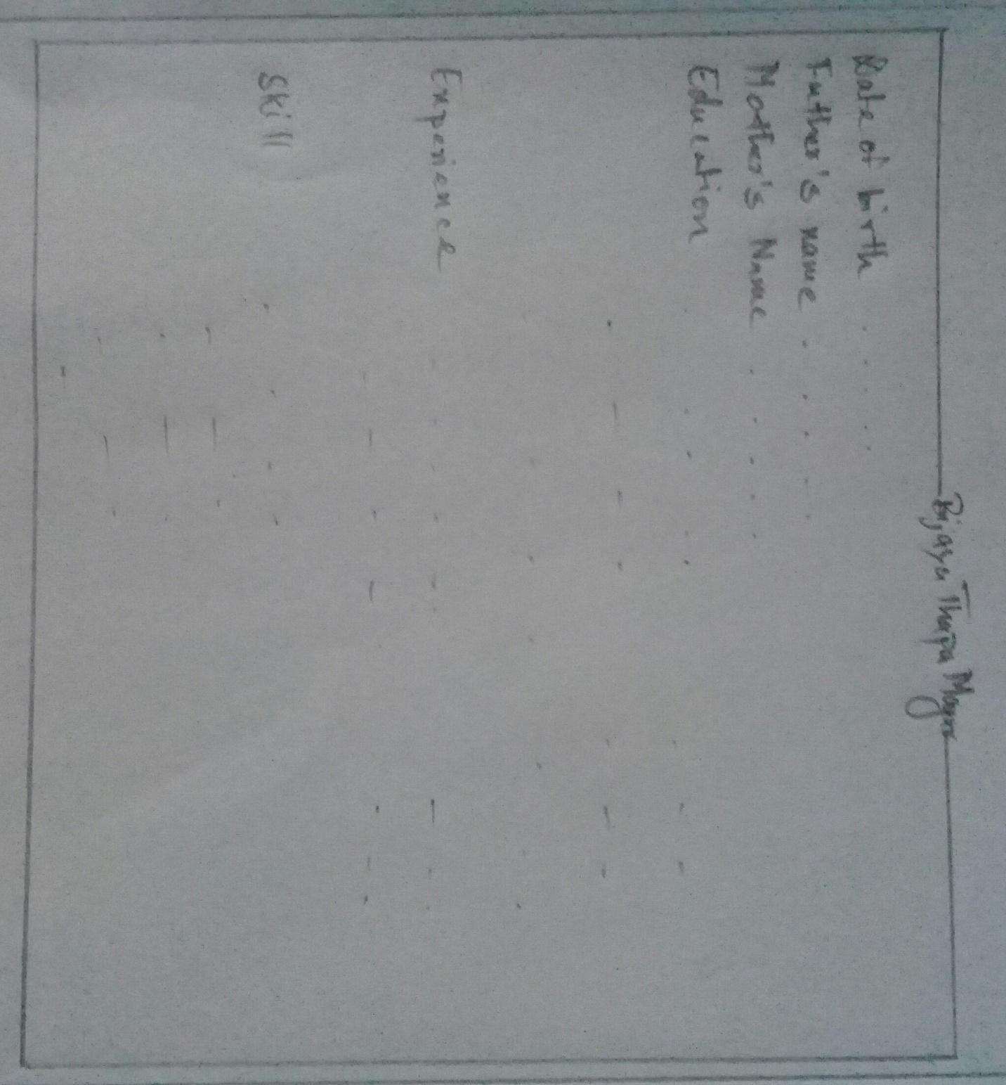**CV Page**

**` Fig 5 Wireframe of CV page**

1. **Screen Mock-up**

Screen mockup is the mockup of screen. Here, I have included the screen mockup.

**Home Page**

Home Page includes my personal photo and a short detail about me. There are different link to different pages.



**Fig 6 Screen Mockup of Home page**

**CV Page**

CV page contains a short CV of mine and links to different pages.

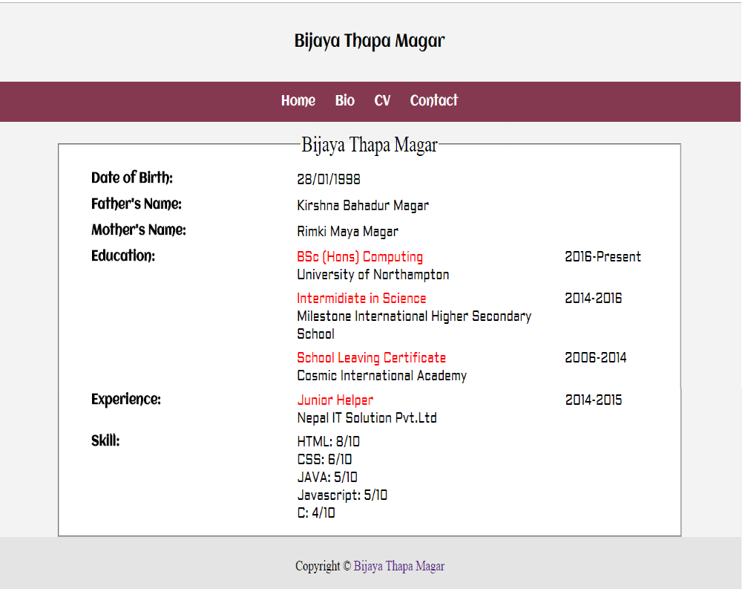

**Fig 7 Screen Mockup of CV page**

**Bio Page**

Bio page includes short bio about me, my photo and links to different pages

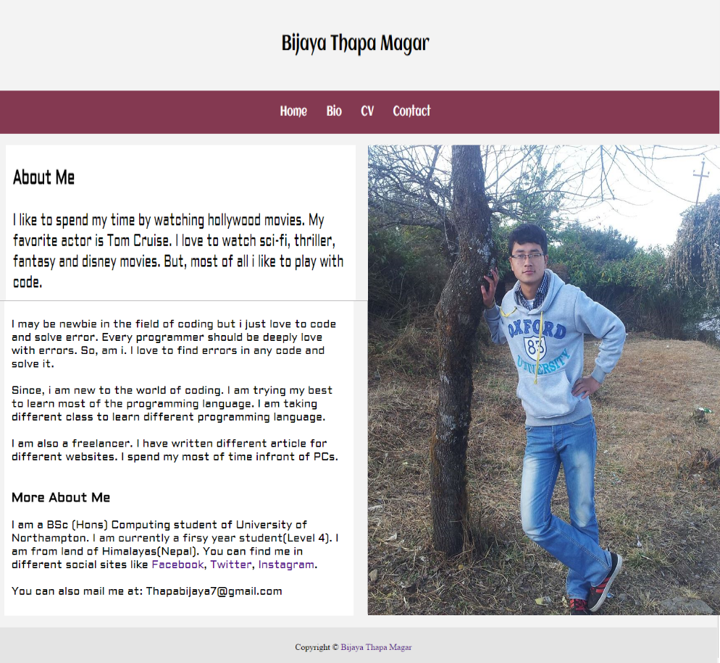

**Fig 8 Screen mockup of Bio Page**

**Contact Page**

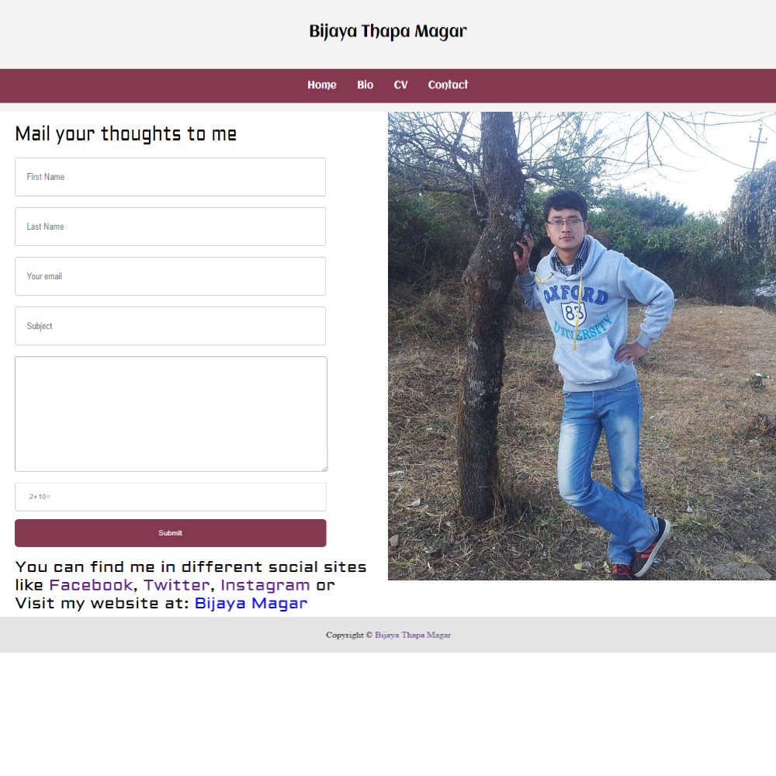 Contact page contents a static form for contacting me and a photo of mine. It also have links to different pages

**Fig 9 Screen mockup of Contact Page**

**5. Testing and Evaluation**

**5.1 Responsive Webpage**

Every webpage of a website should be responsive. Responsive of a webpage means webpage can adapt the height and width of the device. Whether, webpage is opened in PC, Mobile or in any device responsive webpages adapt the width and height of the device. Responsive webpage is easy to use and handle. So, every webpage should be responsive. After, testing my site I found out that my site is responsive and easy to use.

**5.2** **Validation of Source Code**

There will be a problem if source code of your webpage is not valid. Every source code should pass the validation test. If a webpage fails to pass the validation, there could be a problem. So, I have checked validity of my webpages. I have used HTML and CSS to build this website. HTML is a language which is used to show content in a webpage and CSS is used to manage the HTML code or. For HTML pages, I used HTML validation and it got success. There were few warnings but we can neglect the warning because it cannot affect the webpages. For CSS files, I used CSS validation. They showed large amount of errors. But, after debugging the errors got removed. By, use of validator I can say my site is valid.

**5.3 Speed Test**

Speed matters in every place. In website also speed matters. Users doesn’t like website which takes more time to load. I test my site and found that my site is fast enough to load.

**5.4 Usability**

Usability in website means how much easy the visitors can find the content. I provided my site to different collogues and found my site was congested. So, they suggested me to edit the site. After, I edited website my collogues found website much easier to use than before.

**6 Conclusion**

It took me about one week to develop this site. After, review from my collogued and users, I am well satisfied with my website. The website I developed is user friendly and easy to use. This website has also passed HTML and CSS validation too. The web page loading speed of the site is good enough. But, everything is not perfect, I think there are also few errors in my site.

**7 Reference**

* W3Schools (2017) CSS Tutorial. W3Schools [online] Available at|: https://www.w3schools.com/CSS [Accessed 28 March 2017]
* W3Schools (2017) CSS3 Transition. W3Schools [online] Available at|: https://www.w3schools.com/CSS/css3_transitions.asp [Accessed 30 March 2017]
* W3Schools (2017) CSS3 Media Quires. W3Schools [online] Available at|: https://www.w3schools.com/CSS/css3_mediaqueries.asp [Accessed 2 April 2017]
* W3Schools (2017) Responsive Web Design – The viewport. W3Schools [online] Available at|: https://www.w3schools.com/CSS/css_rwd_viewport.asp [Accessed 4 April 2017]
* W3Schools (2017) CSS Fonts. W3Schools [online] Available at|: https://www.w3schools.com/CSS/css_font.asp [Accessed 6 April 2017]